# CS 255 System Design Document Template

This template lays out all the different sections that you need to complete for Project Two. Each section has guidance to prompt your thinking. You will need to continually reference the interview transcript as you work to make sure that you are addressing your client’s needs. There is no required length for the final document. Instead the goal is to complete each section based on what your client’s needs are. Remove this note when you are finished, and replace all bracketed text with the relevant information.

## UML Diagrams

### UML Use Case Diagram

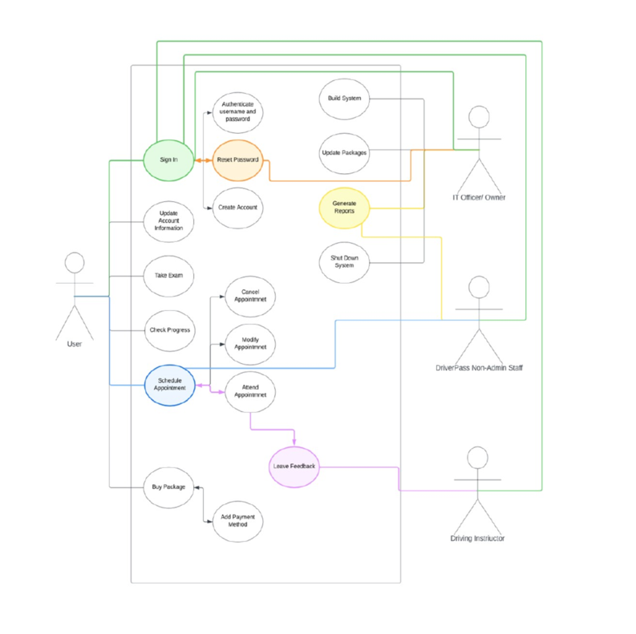

### UML Activity Diagrams

package:



login:

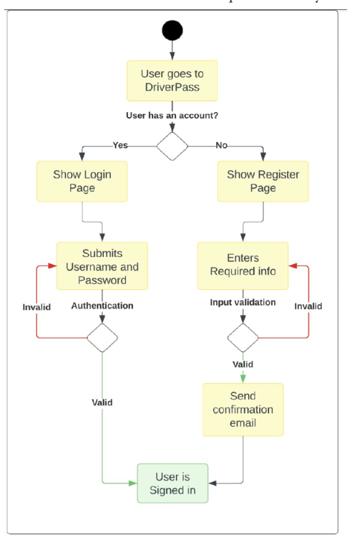

### UML Sequence Diagram

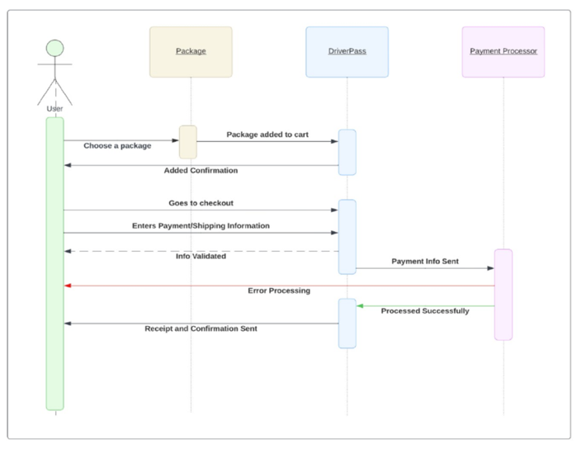

### UML Class Diagram

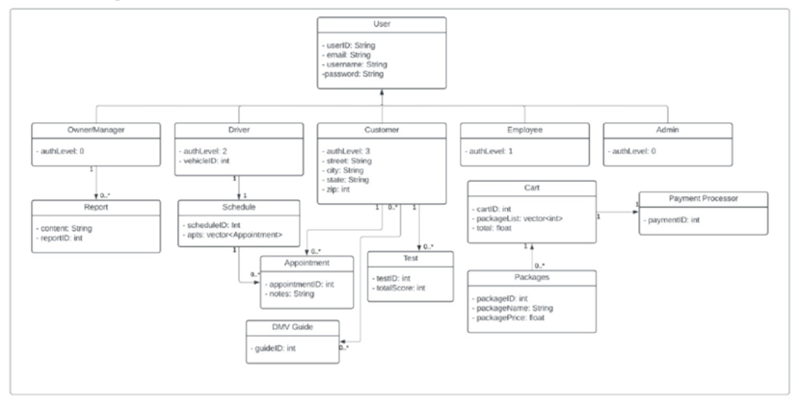

## Technical Requirements

To set up the system, certain hardware is needed. This includes a dedicated server, a steady internet connection, and enough storage space to hold both the website and database information. People also need to be able to access the site from a computer or mobile device. A firewall should be used to protect the website’s ports and keep the system safe from outside threats.

On the software side, it's recommended to use Windows Server because it is reliable. For the database, SQL Server is a good choice since it’s stable. Backup software should be used to regularly save copies of both the website and the database, just in case something goes wrong. A web server, like Apache, is needed to host the site, and security software should be added to protect against viruses and malware.

The website needs to be available to users in the United States. The website and database should be stored in a secure data center, and the server should be placed in a location that helps keep the site running smoothly and quickly for everyone.